Comprehensive Assembly and Bring-Up Guide: Ultrasonic Spirometer Prototype
Phase 1: Transducer Mounting & Acoustic Sealing
The physical integration of the ultrasonic sensors is the most critical step for ensuring clean analog captures.
- Transducer Sealing: Insert the Jiakang 200kHz transducers into the designated upstream and downstream ports of the plastic flow pipe. It is imperative to ensure an absolutely airtight fit. Even microscopic air leaks will alter the internal pressure dynamics, introduce turbulent flow vectors, and drastically skew the Time-of-Flight (ToF) calculations. Use appropriate gaskets, O-rings, or a non-permanent silicone sealant around the transducer housings to prevent any flow leakage.
- Alignment: Ensure the active faces of the transducers are perfectly aligned and seated flush within their designated angled mounts. Misalignment will cause the acoustic beam to bounce erratically off the pipe walls, degrading the signal envelope reaching the receiver.
Phase 2: Analog Front-End Wiring (TX1 / RX1)
Connecting the transducers to the MCU’s Ultrasonic Sensing Solution (USS) analog front end requires careful attention to signal integrity.
- Routing: Route the positive and negative leads of the upstream and downstream transducers to the respective TX1 and RX1 input/output pins on the custom MSP430FR6043 PCB.
- Parasitic Capacitance Mitigation: Keep these analog lead wires as short as physically possible. Long or bundled wires can introduce parasitic capacitance and act as antennas for electromagnetic interference (EMI), which will distort the high-frequency 200kHz waveforms before they reach the high-speed ADC.
Phase 3: Telemetry Hookup via FTDI Adapter
To safely establish the data pipeline for your host-side applications (like the Python GUI) without causing ground loops or voltage mismatches, a dedicated FTDI serial adapter is required.
- Logic Level Verification: CRITICAL: Before connecting anything, ensure your FTDI adapter is set to 3.3V logic levels (often done via a physical jumper on the FTDI board). The MSP430FR6043 operates at 3.3V; feeding it a 5V UART signal will permanently damage the microcontroller's RX pin.
- Pin Crossover: Connect the custom board's UART TX pin to the FTDI adapter's RX pin. (The FTDI adapter's TX pin is left unconnected unless your host application requires sending commands back to the MCU).
- Common Ground: Connect the custom board's GND to the FTDI's GND.
- Note on Power: Do not connect the FTDI’s VCC/Power pin to the custom board. The board will be powered entirely by the EVM in the next step.
Phase 4: Power, SBW Programming Interface, & Flashing
To program the custom PCB, you will bypass the EVM430FR6043’s onboard MCU and use its integrated ezFET debugger to flash your external target via the Spy-Bi-Wire (SBW) protocol.
- Hardware Bridge Setup:
  - TEST Pin (SBWTCK): Route a jumper wire from the TEST pin of the custom board to the corresponding TEST pin on the EVM board's programming header.
  - RST Pin (SBWTDIO): Route a jumper wire from the RST (Reset) pin of the custom board to the RST pin on the EVM board.
- Power Delivery: Supply clean power to the custom board by routing a wire from the EVM's J2 jumper 3V3 pin to the custom board's 3V3 input, and similarly connect the GND from the EVM to the custom board's GND.
- Firmware Deployment: Once the hardware bridge is physically verified, supply USB power to the EVM. Launch either Code Composer Studio (CCS) for live debugging or the Texas Instruments Uniflash tool for direct flashing.
- Verification: Before hitting "Flash," verify you have compiled the correct .out binary—specifically, the version containing the critical hardware timing patch (the 5000 μs settling time to accommodate the new crystal oscillator) and the dynamic low-power capture mode toggles. Once flashed, the custom board will automatically reboot and begin streaming calibrated telemetry to your FTDI-connected host PC.
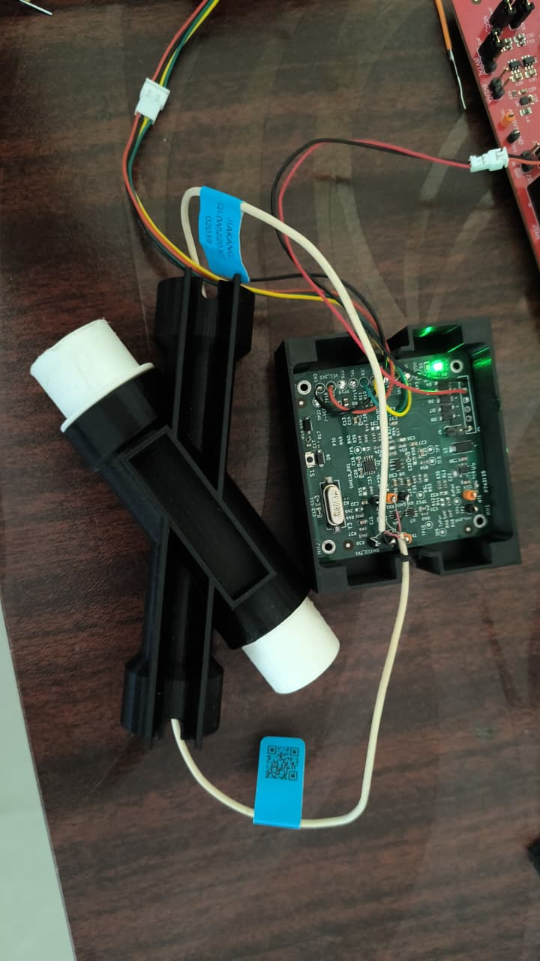
Fig: Connection Setup of the Spirometer

